# Loop AWS Config

Loop need S3, CloudFront, SQS, SES, IAM as core dependency, below will show how to create these components.

All customer config in this file: **annotation-service/config/app-os.js**

|  |  |  |  |  |
| --- | --- | --- | --- | --- |
| **Index** | **Version** | **Brief Description** | **Name** | **Time** |
| 1 | V0 | Aws config draft include s3, cloudfront, sqs, ses, ima | Joe Qiao | 2021/01/06 |
| 2 |  |  |  |  |
|  |  |  |  |  |
|  |  |  |  |  |
|  |  |  |  |  |
|  |  |  |  |  |

## Login

Login to AWS console: <https://console.aws.amazon.com/console/home>

Please Note create all AWS component in the same region

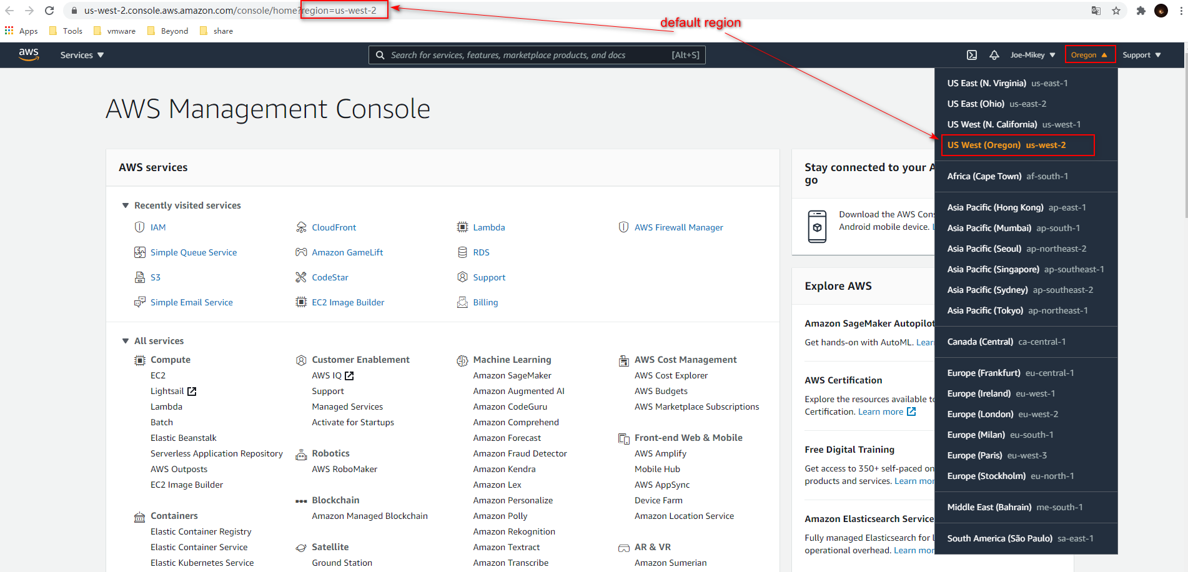

## Replace region

|  |
| --- |
| region: process.env.REGION || "us-west-2" |

# **S3**

You can reference the official guideline from here https://docs.aws.amazon.com/s3/index.html

## Create Bucket

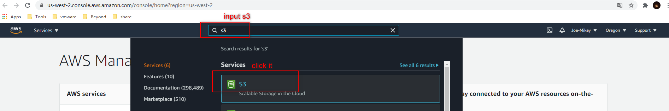

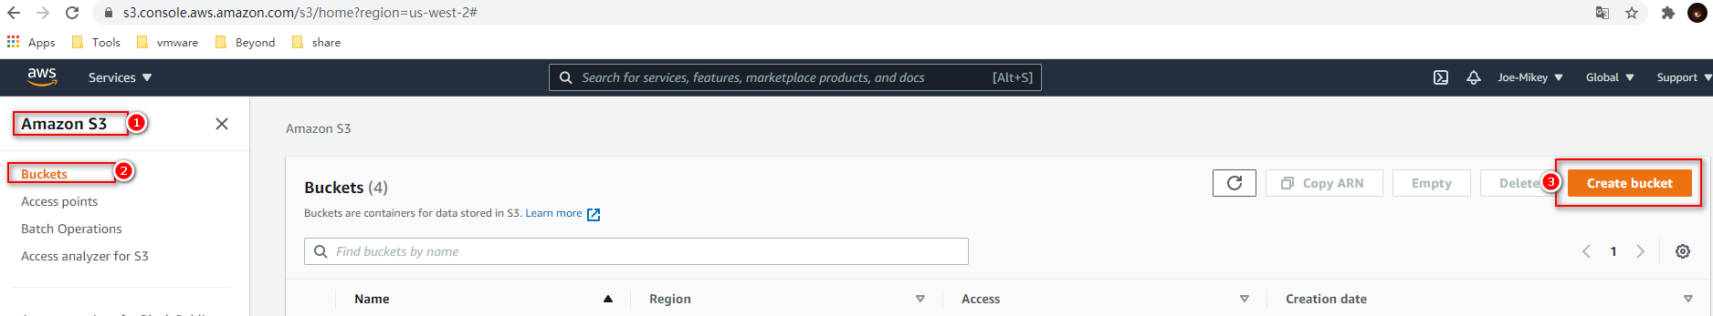

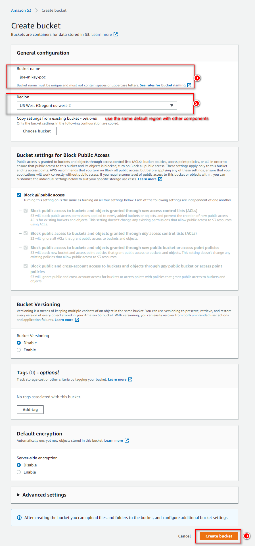

## Replace bucketName

|  |
| --- |
| bucketName: process.env.BUCKET_NAME || "joe-mikey-poc" |

## Edit Bucket permissions

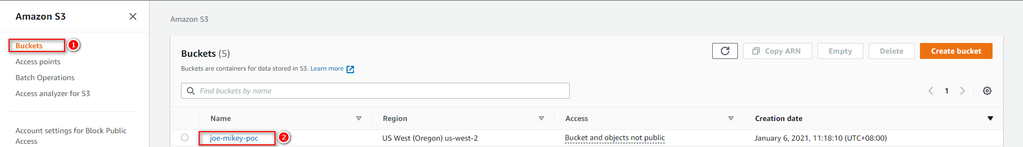

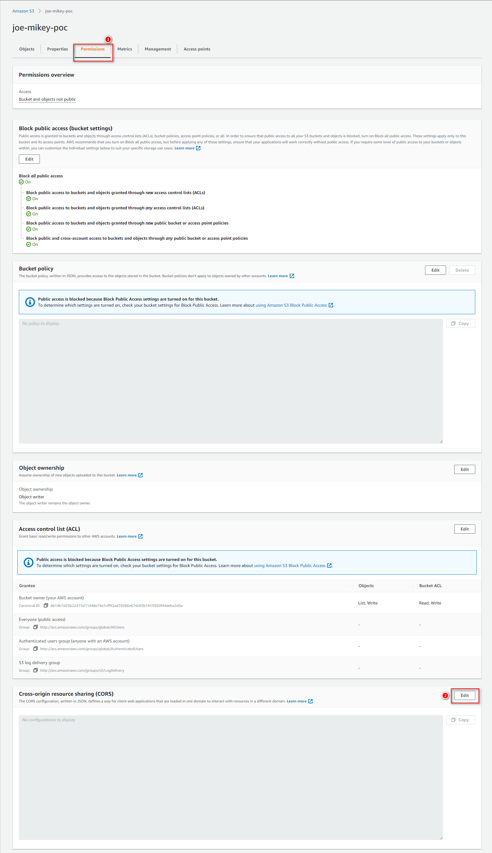

Copy this json the edit input text-area

[

{

"AllowedHeaders": [

"*"

],

"AllowedMethods": [

"GET",

"PUT",

"POST",

"DELETE"

],

"AllowedOrigins": [

"*"

],

"ExposeHeaders": []

}

]

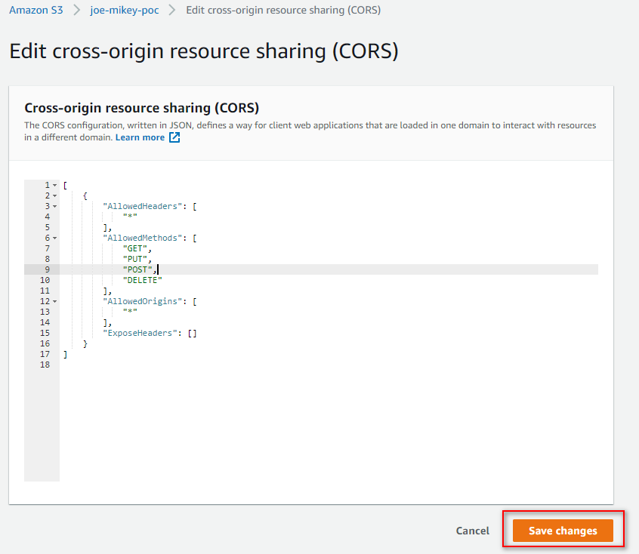

# **CloudFront**

You can reference the official guideline from here https://docs.aws.amazon.com/cloudfront/index.html

## Create cloudFront Credentials

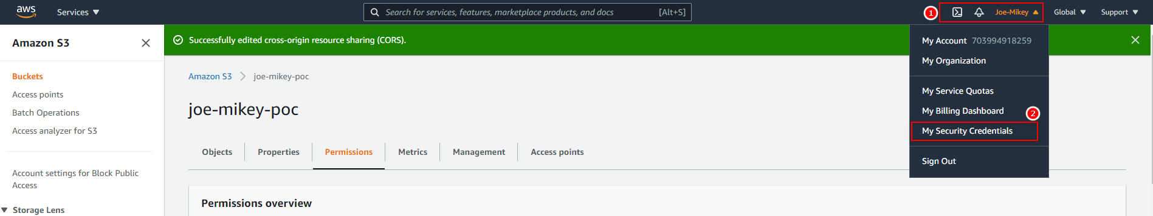

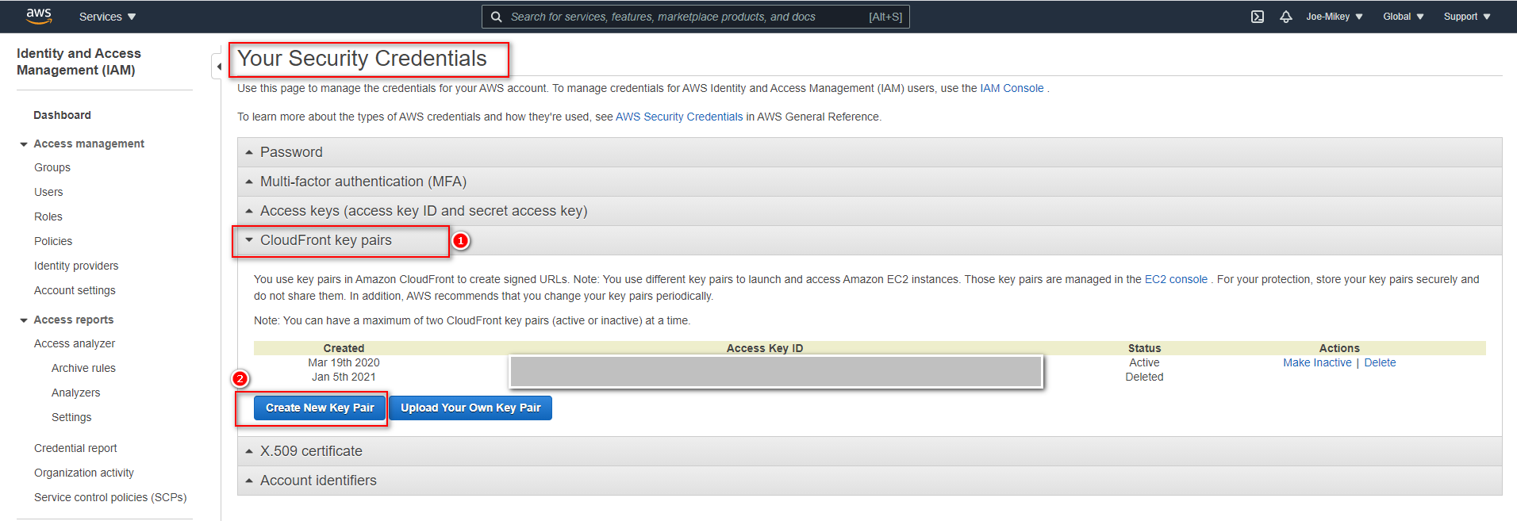

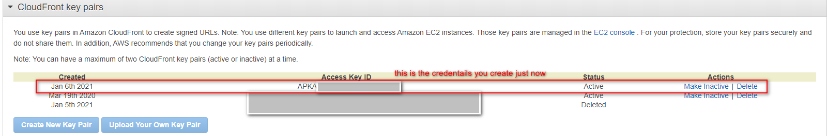

## Put cert

Put the download cert file into this folder: **annotation-service/config/cert/**

## Replace cloudFrontAccessKeyId, cloudFrontPrivateCert

|  |
| --- |
| cloudFrontAccessKeyId: process.env.CLOUDFRONT_ACCESS_KEY_ID || "xxxxxx"  cloudFrontPrivateCert: process.env.CLOUDFRONT_PRIVATE_CERT || "xxxxx.pem" |

## Create Origin Access Identity

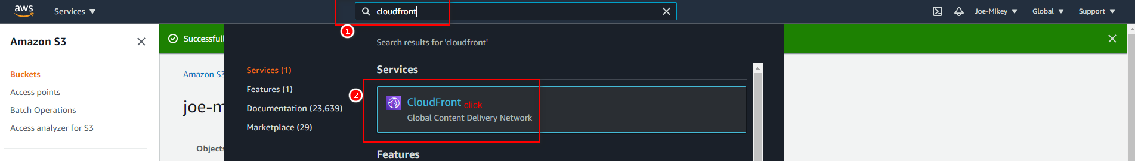

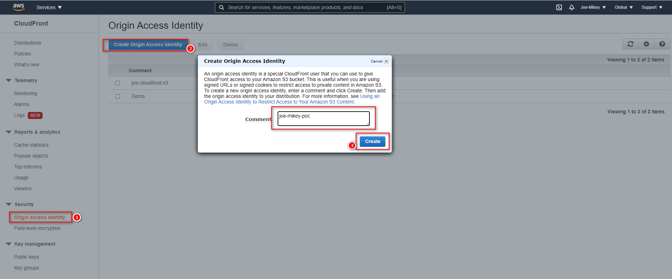

## Create CloudFront

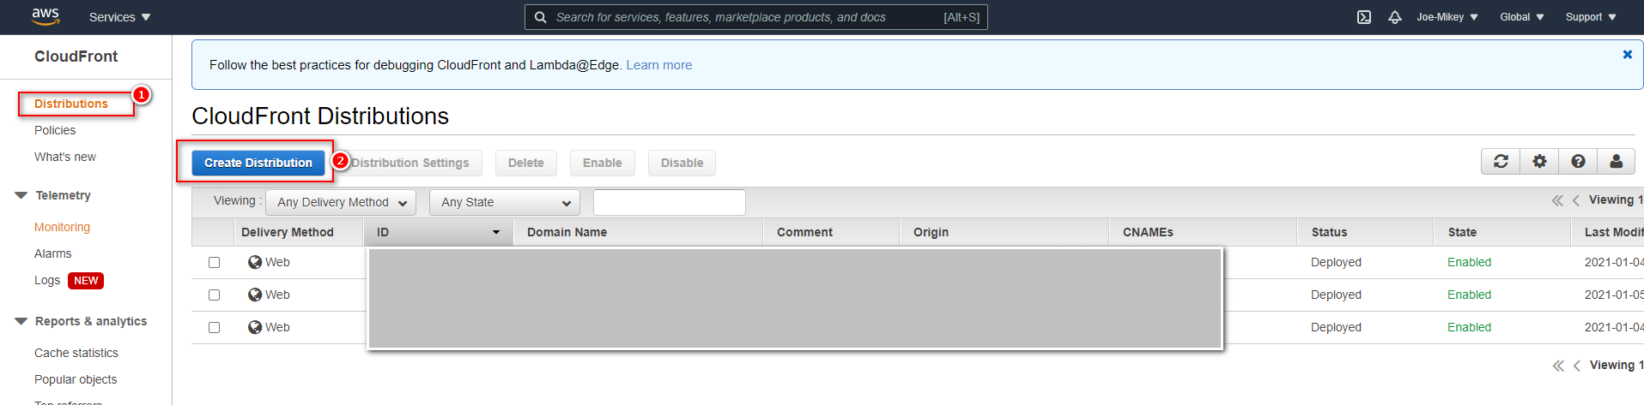

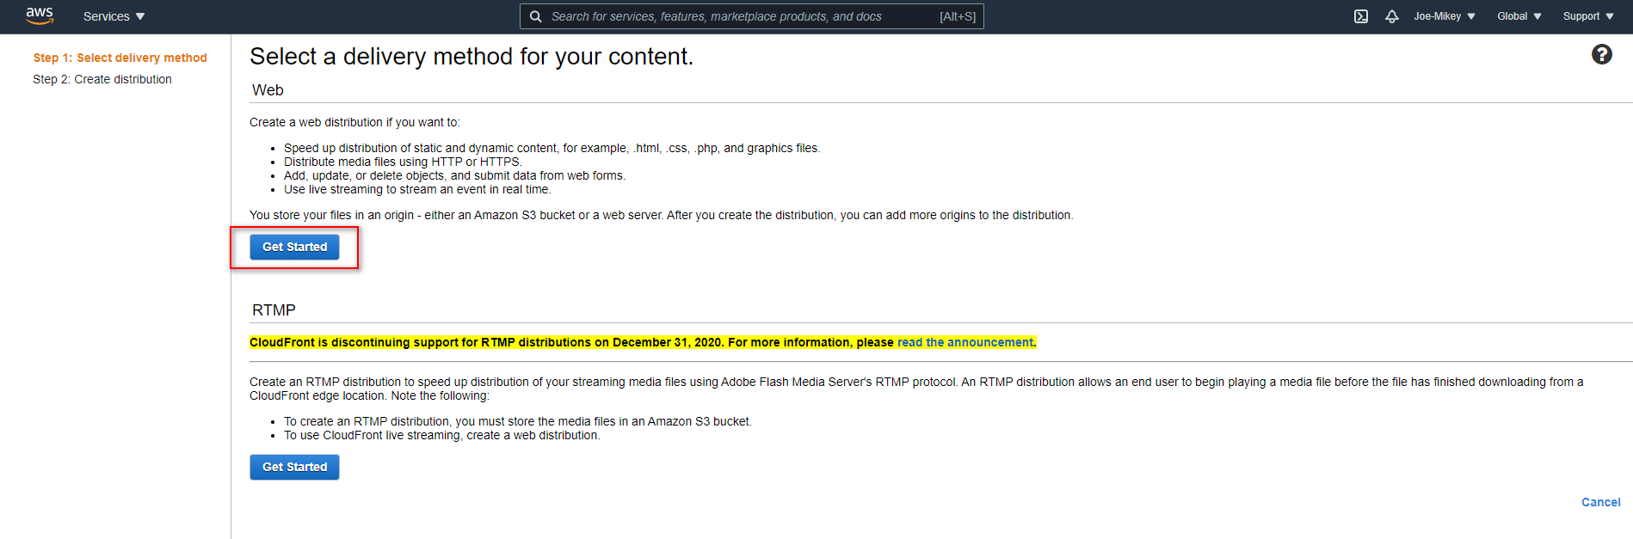

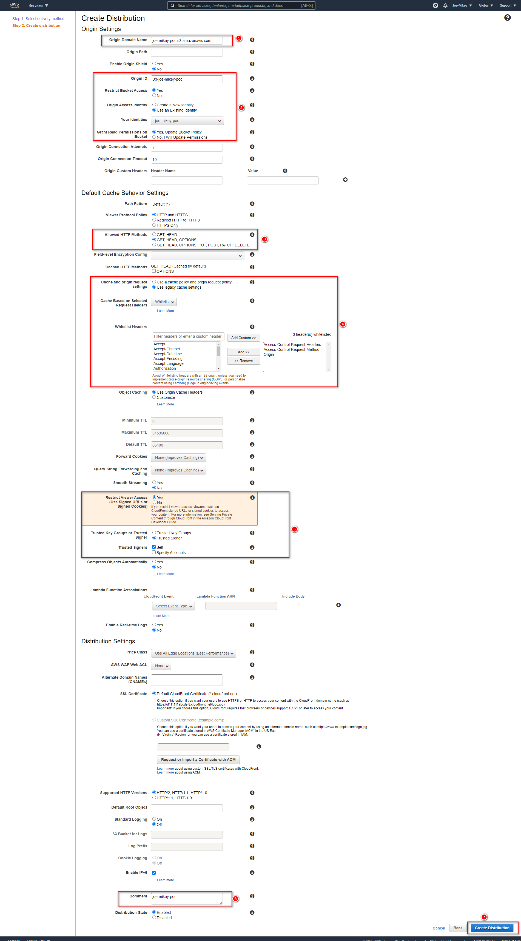

## Replace cloudFrontUrl

Copy the Domain Name and replace the cloudFrontUrl with a https link

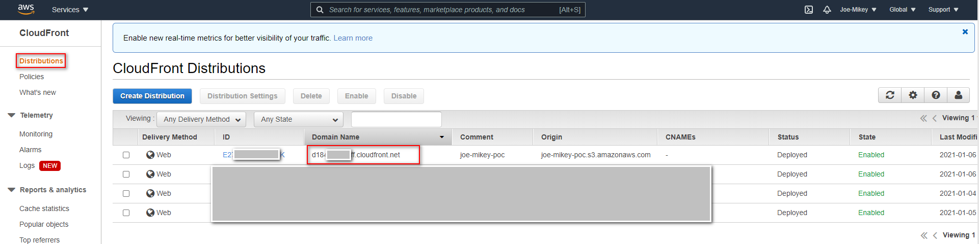

|  |
| --- |
| cloudFrontUrl: process.env.CLOUD_FRONT_URL || "https://xxxx.cloudfront.net" |

# **SQS**

You can reference the official guideline from here <https://docs.aws.amazon.com/sqs/index.html>

## Create queue

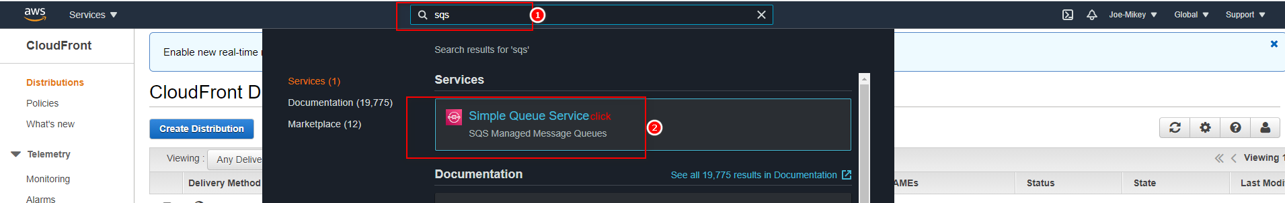

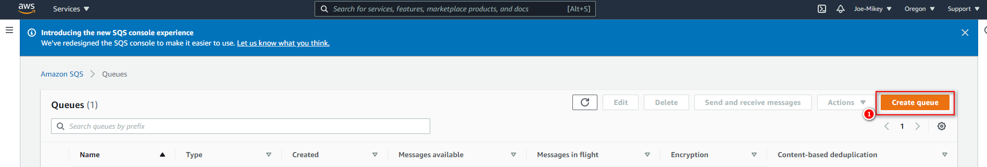

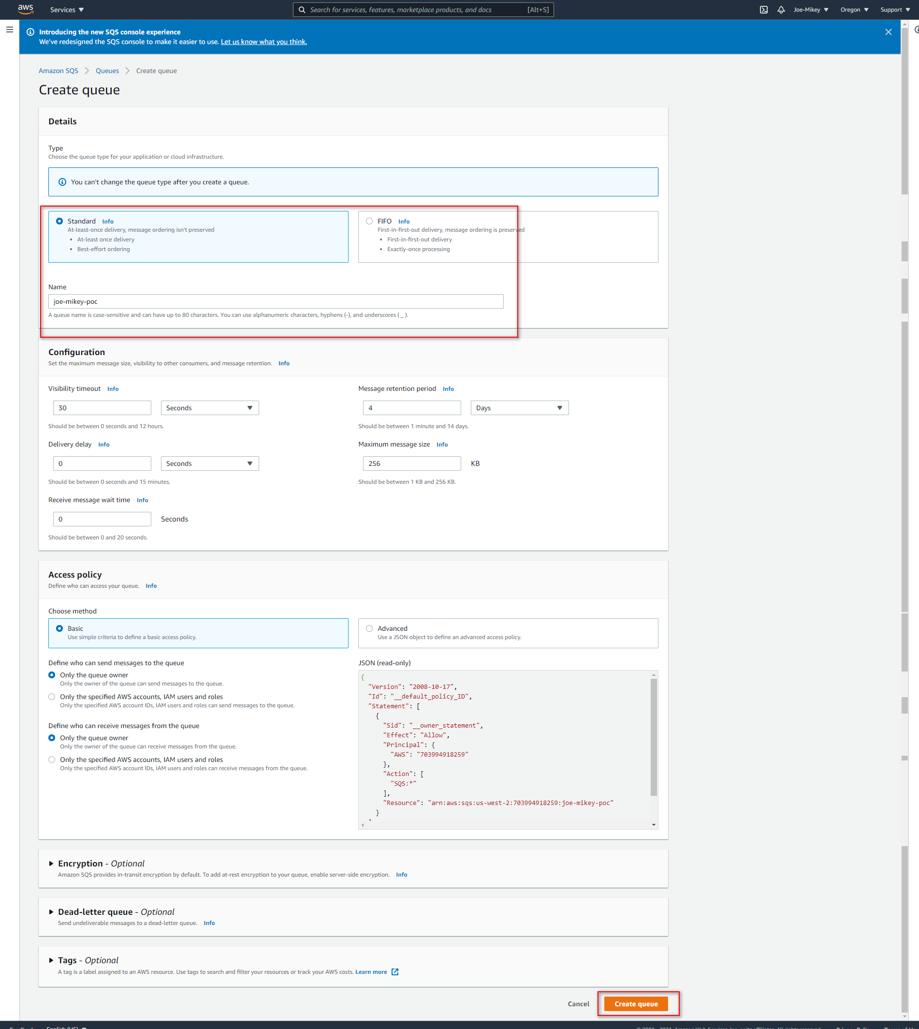

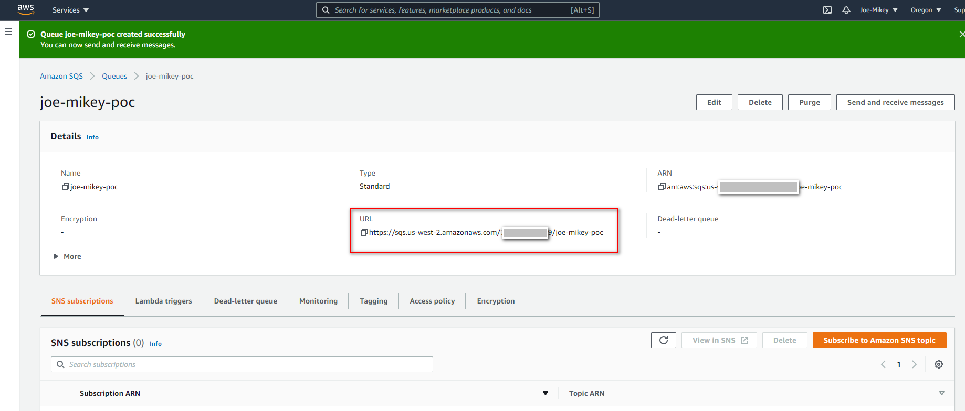

## **Replace sqsUrl**

|  |
| --- |
| sqsUrl: process.env.SQS_URL || <https://sqs.us-west-2.amazonaws.com/xxx/joe-mikey-poc> |

# **SES 【optional】**

If you want to use AWS SES as the email service, you can config this settings below, otherwise you can skip this part.

You can reference the official guideline from here https://docs.aws.amazon.com/ses/index.html

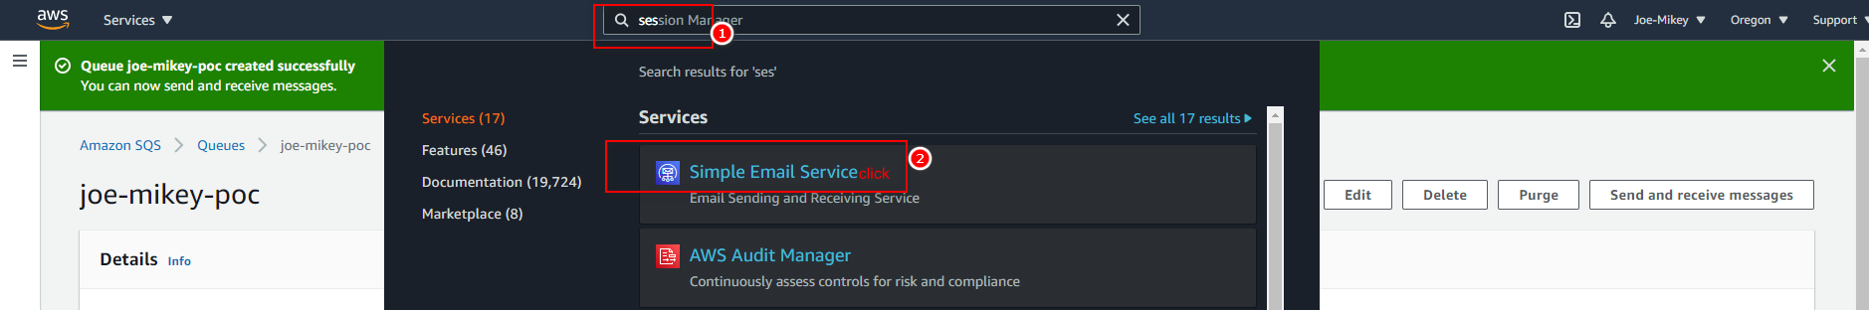

## Sandbox

Sandbox environment need validation sender and to email address.

### Email address verification

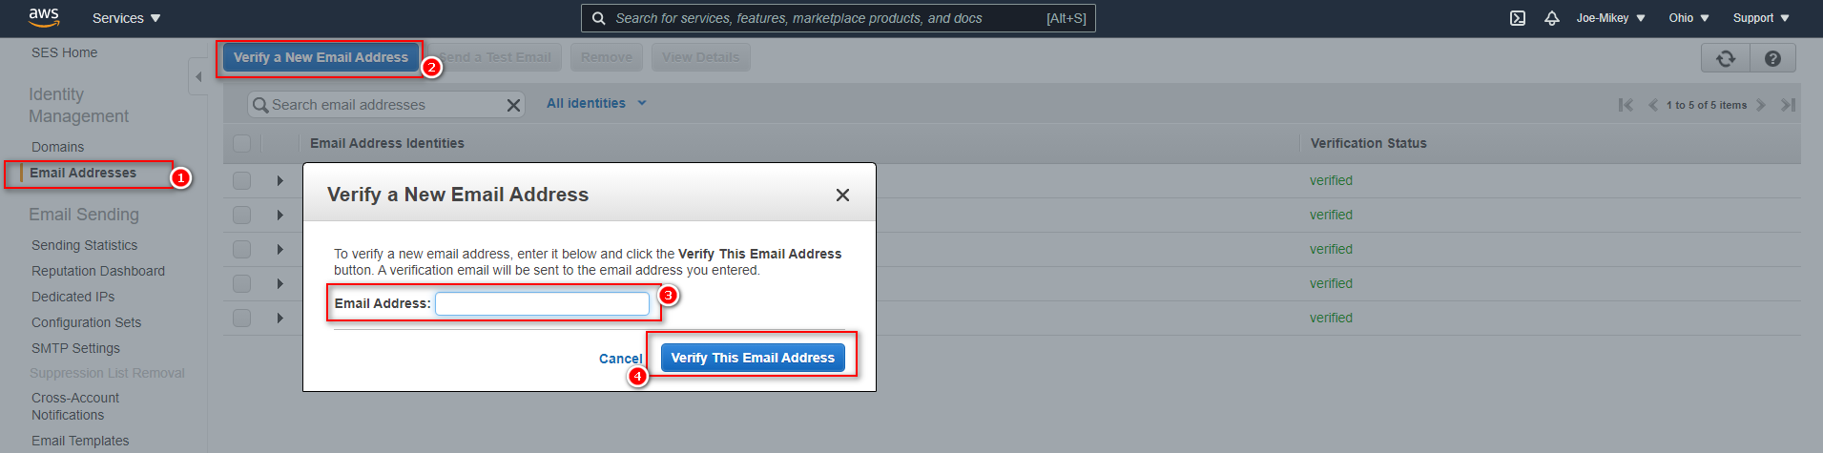

### Domain verification

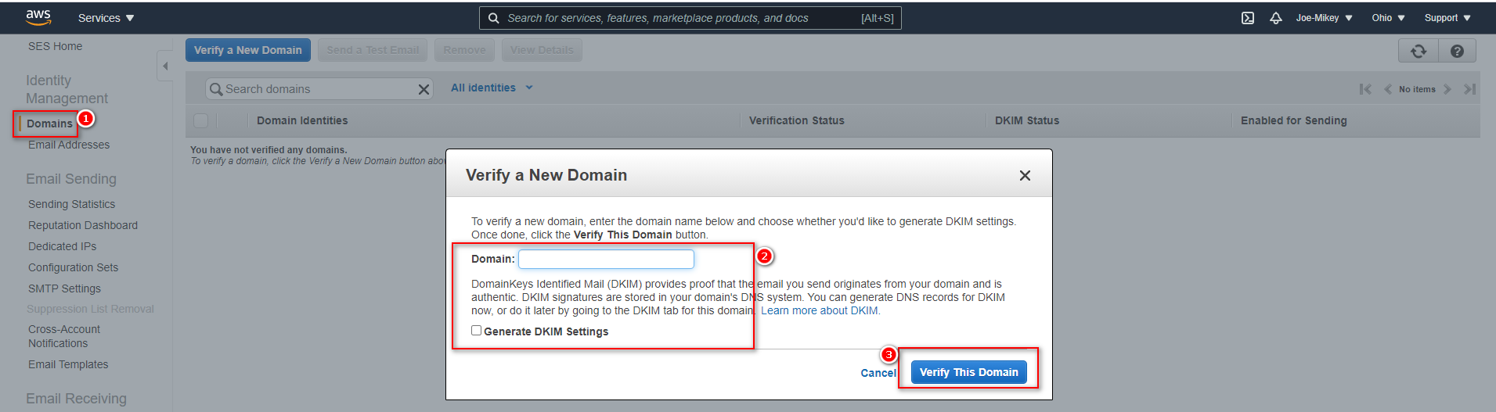

## Production

Production environment can send email to any email address, but need raise application from aws team.

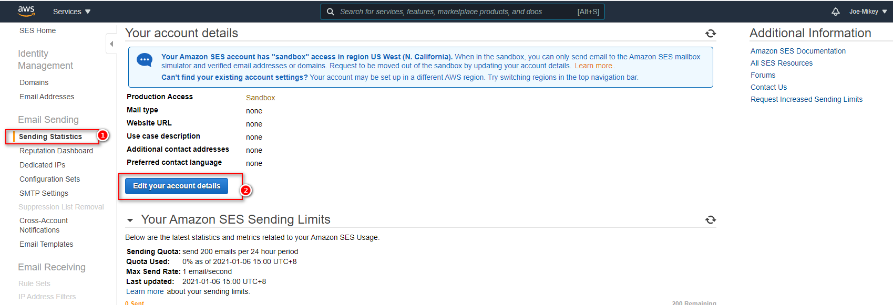

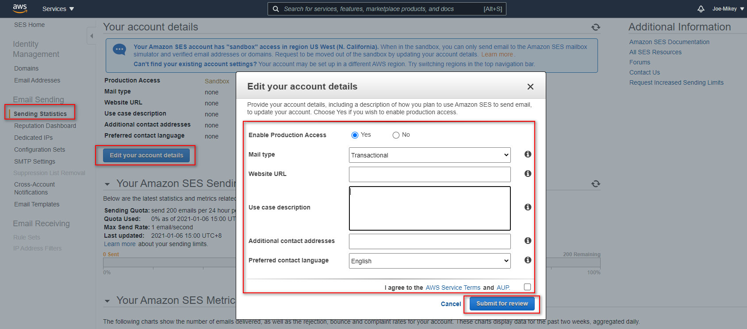

## Replace enableEmail, useAWSSES, sender

if you want enable send email function and want to use AWS SES as the email service replace the sender, and change enableEmail to true and change useAWSSES to true

|  |
| --- |
| enableEmail: process.env.ENABLE_EMAIL || true  ​useAWSSES: process.env.USE_AWS_SES || true  sender: process.env.EMAIL_FROM || "xxx@xxx.com" |

# **IAM**

You can reference the official guideline from here https://docs.aws.amazon.com/iam/index.html

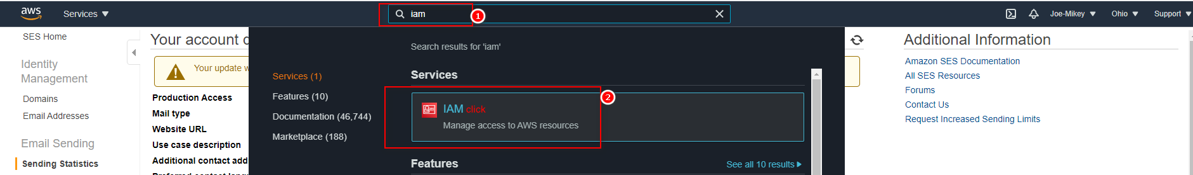

## Create policy

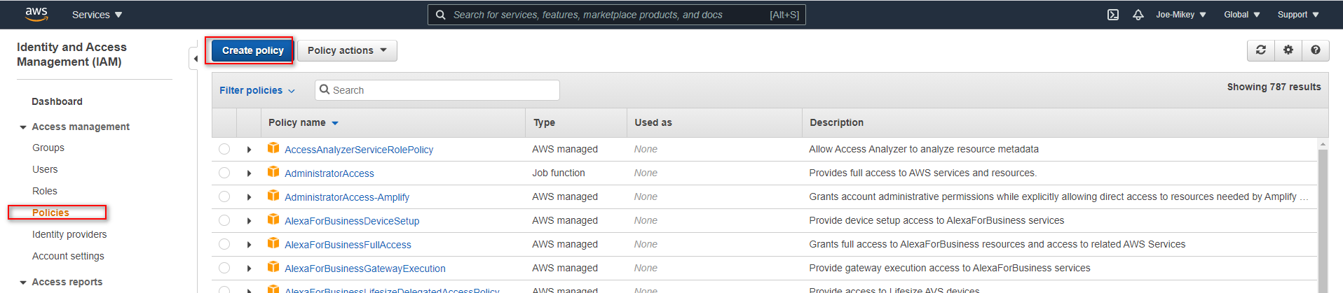

Copy the json to the text-area

{

"Version": "2012-10-17",

"Statement": [

{

"Sid": "VisualEditor0",

"Effect": "Allow",

"Action": [

"ses:*",

"s3:*",

"sqs:*"

],

"Resource": "*"

}

]

}

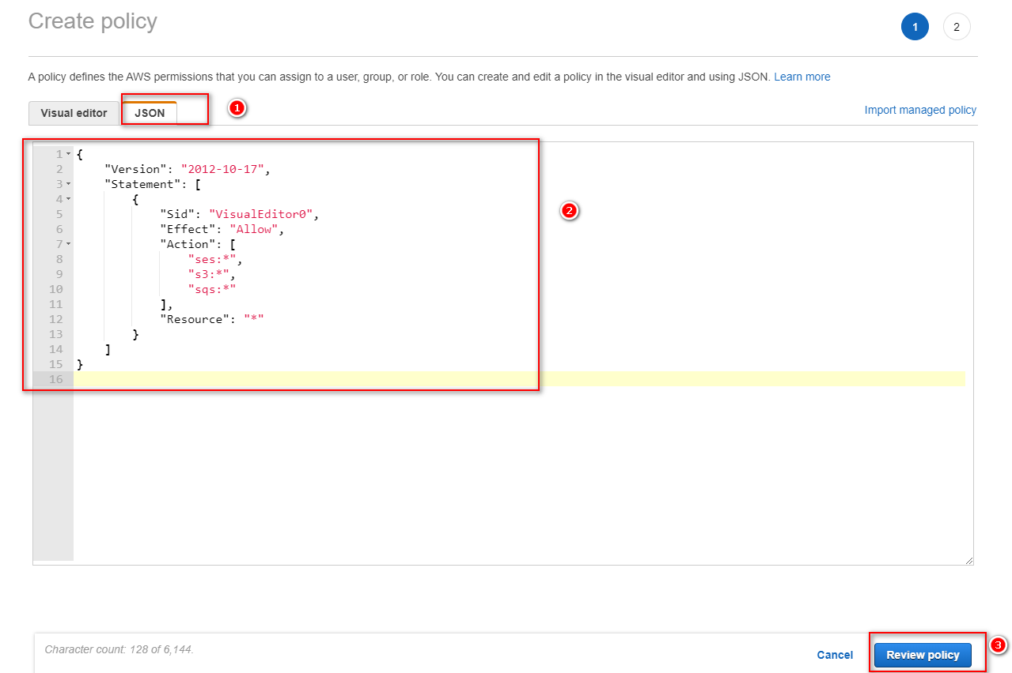

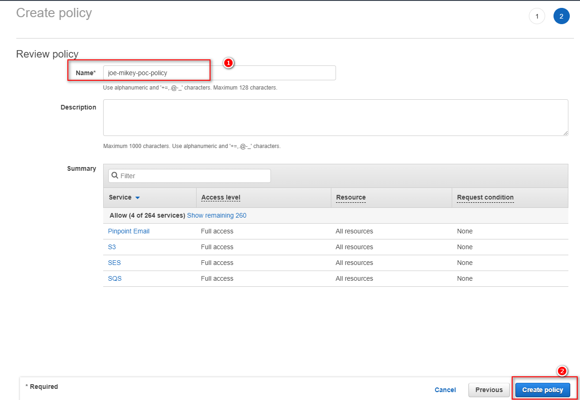

## Create user

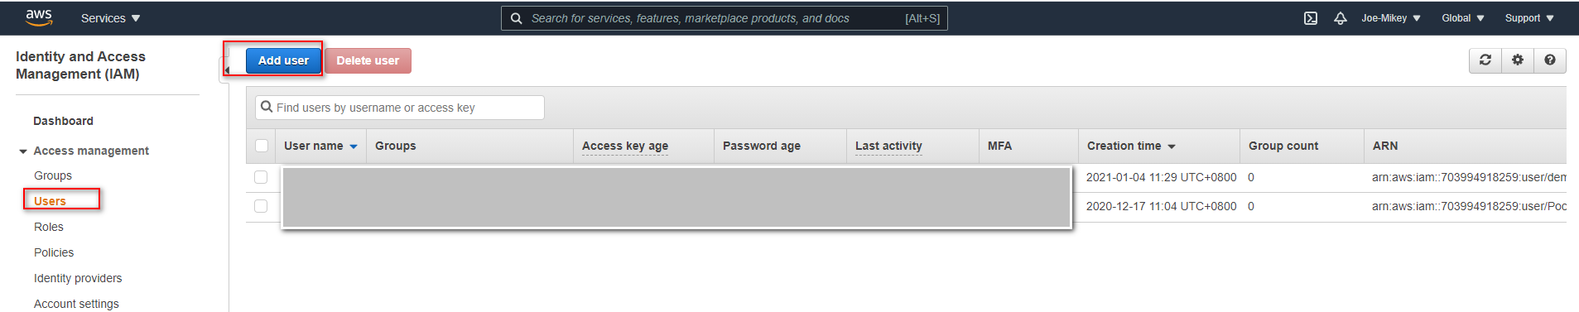

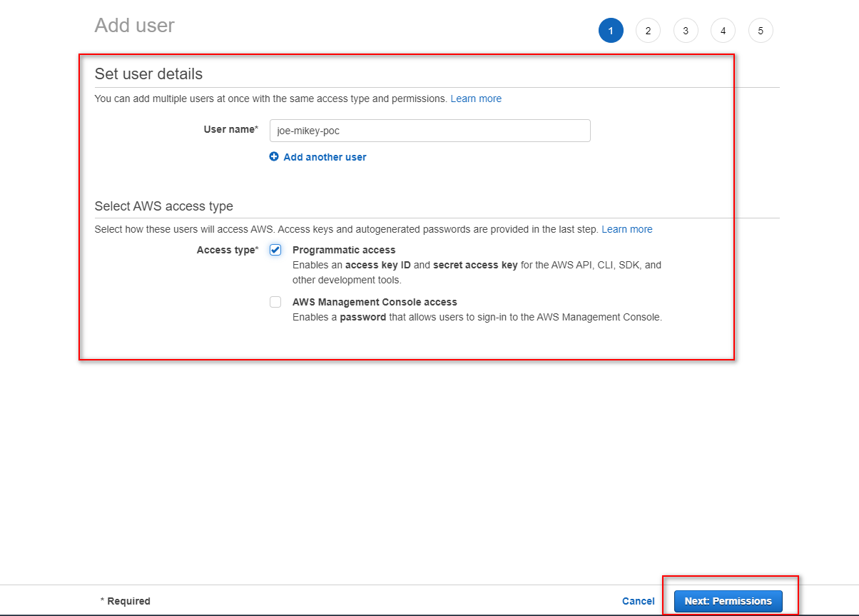

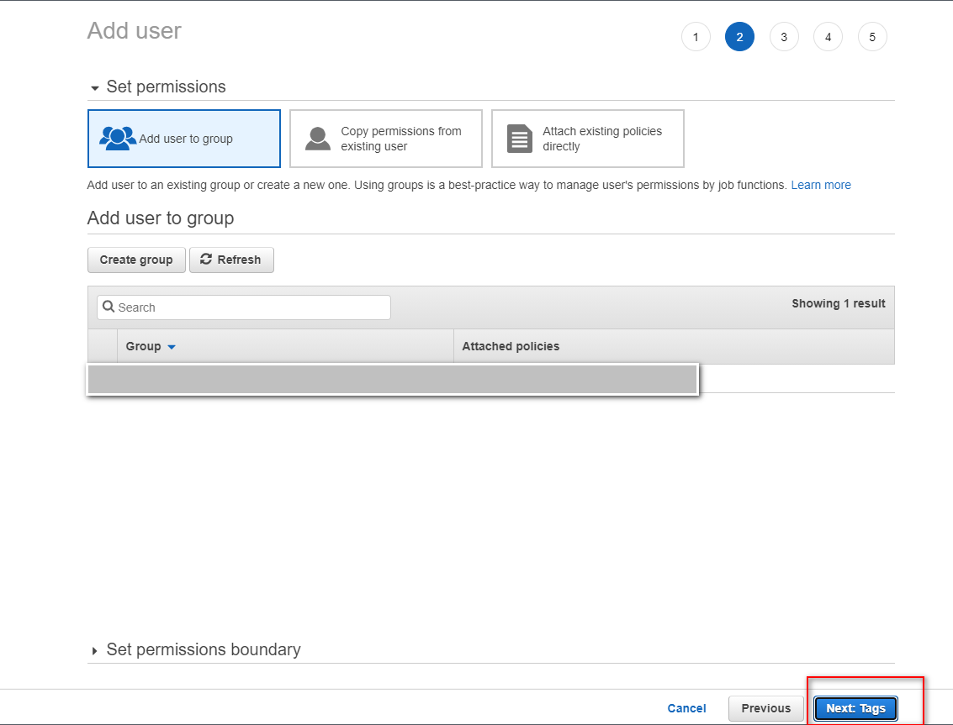

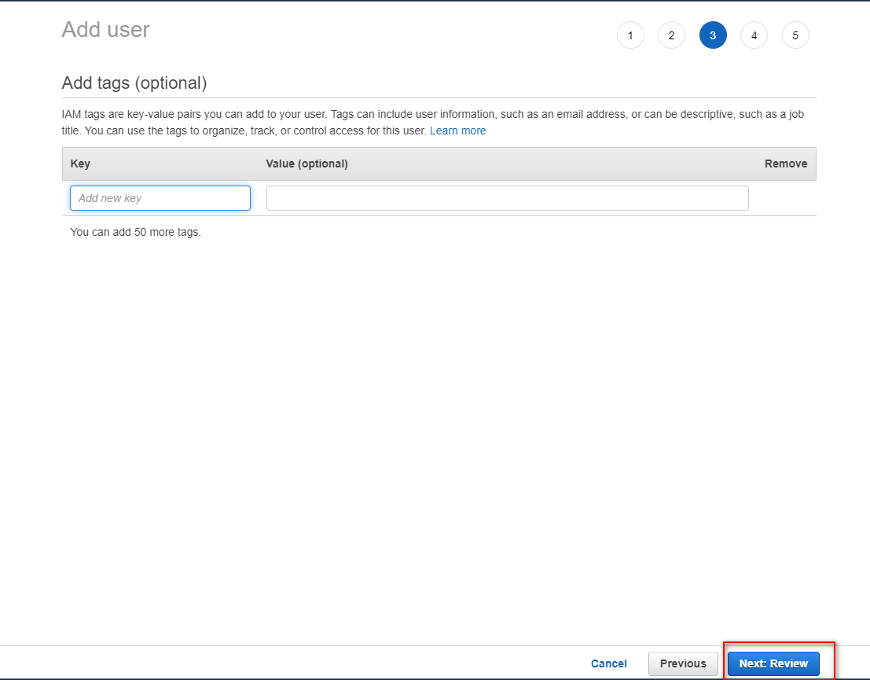

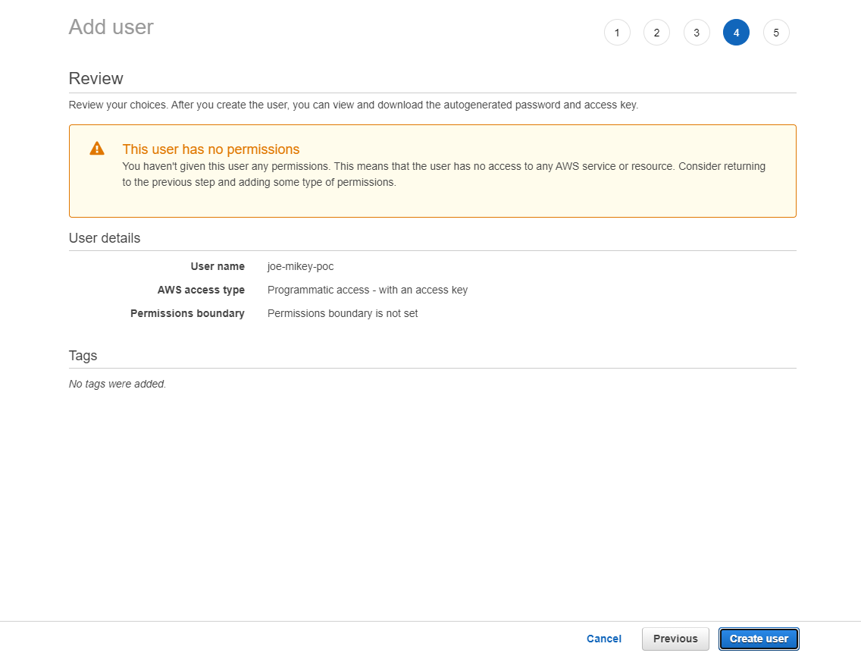

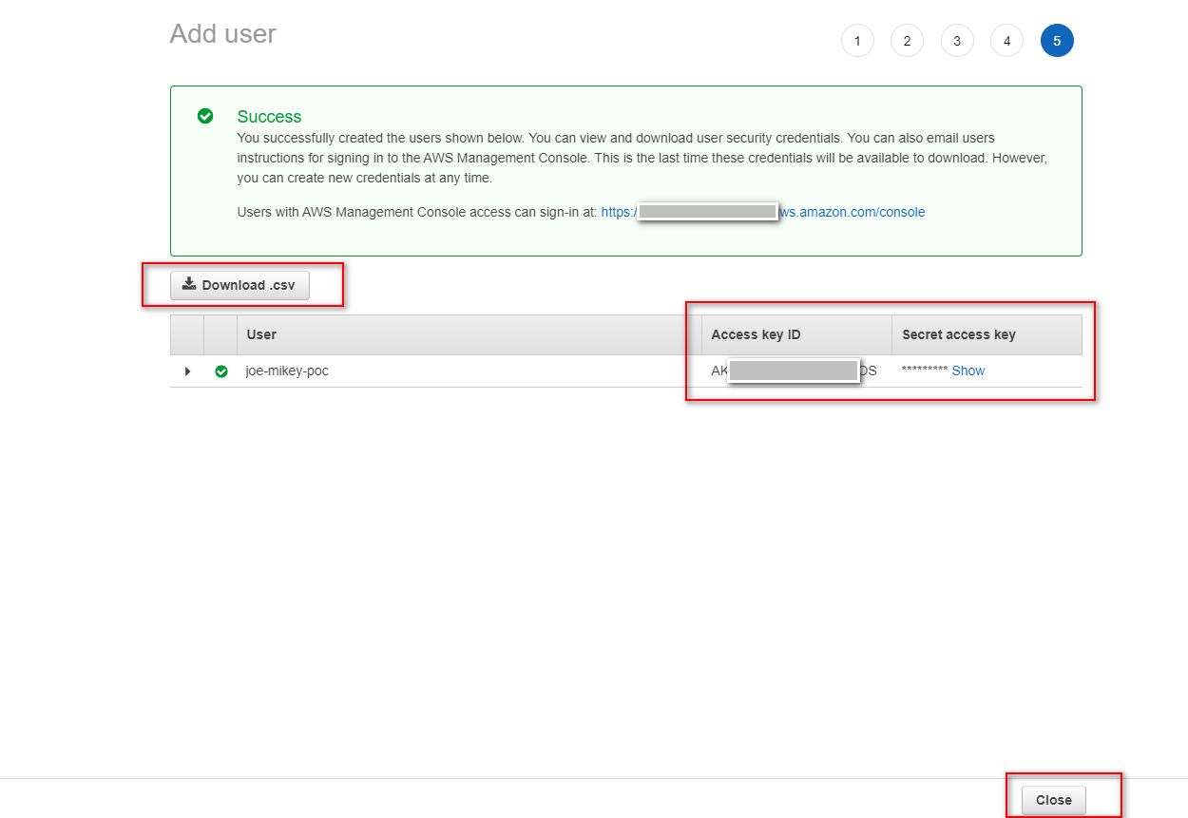

## Replace accessKeyId, secretAccessKey

|  |
| --- |
| accessKeyId: process.env.ACCESSKEY_ID || "xxxxxxxxx"  secretAccessKey: process.env.SECRET_ACCESS_KEY || "xxxxxxxxx" |

## Create role

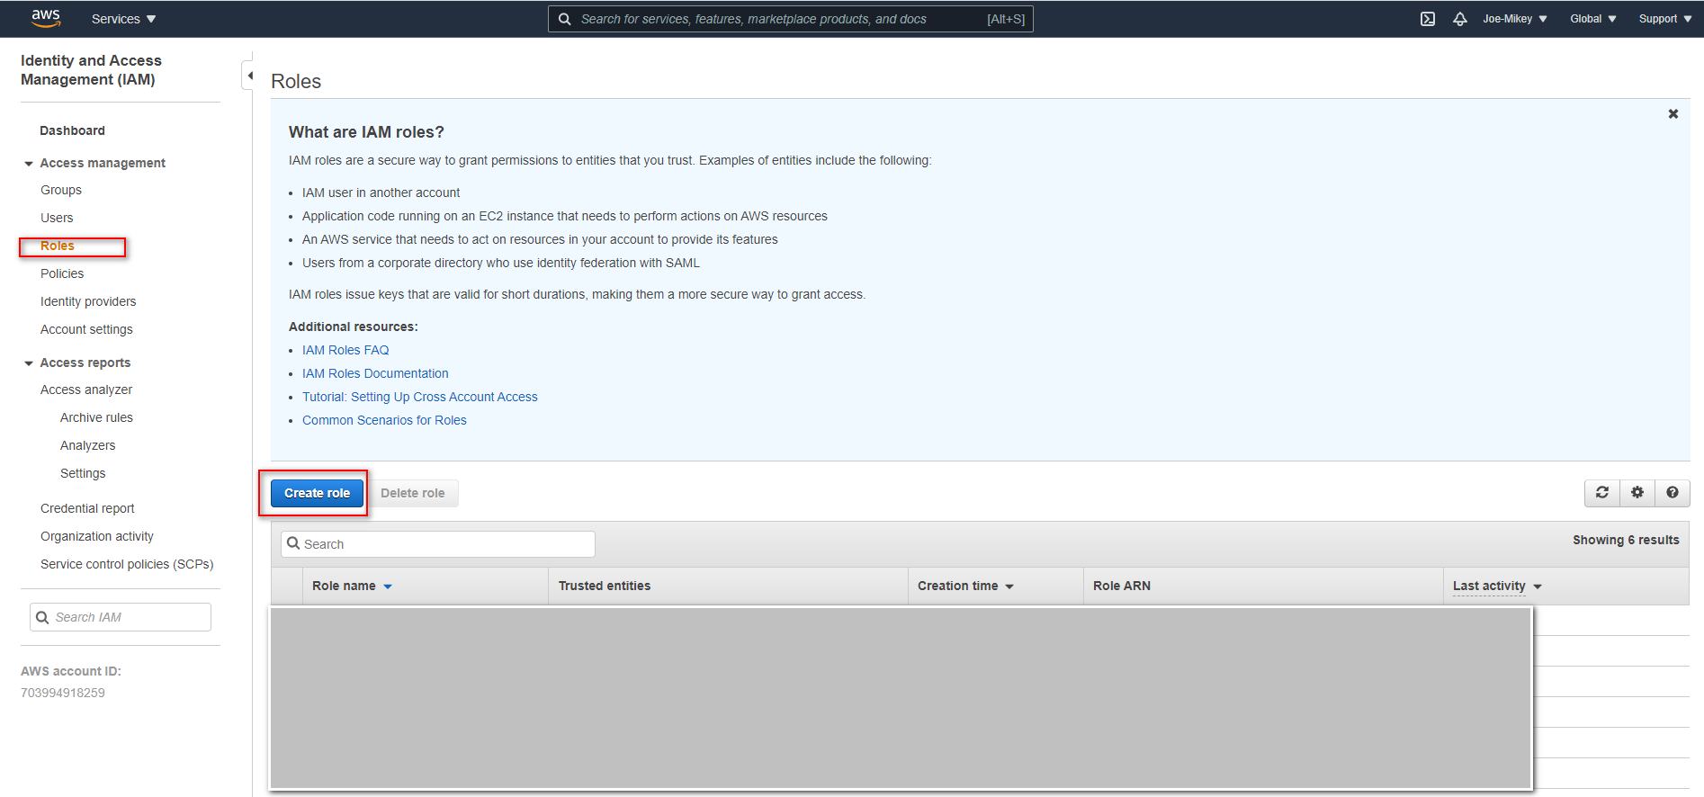

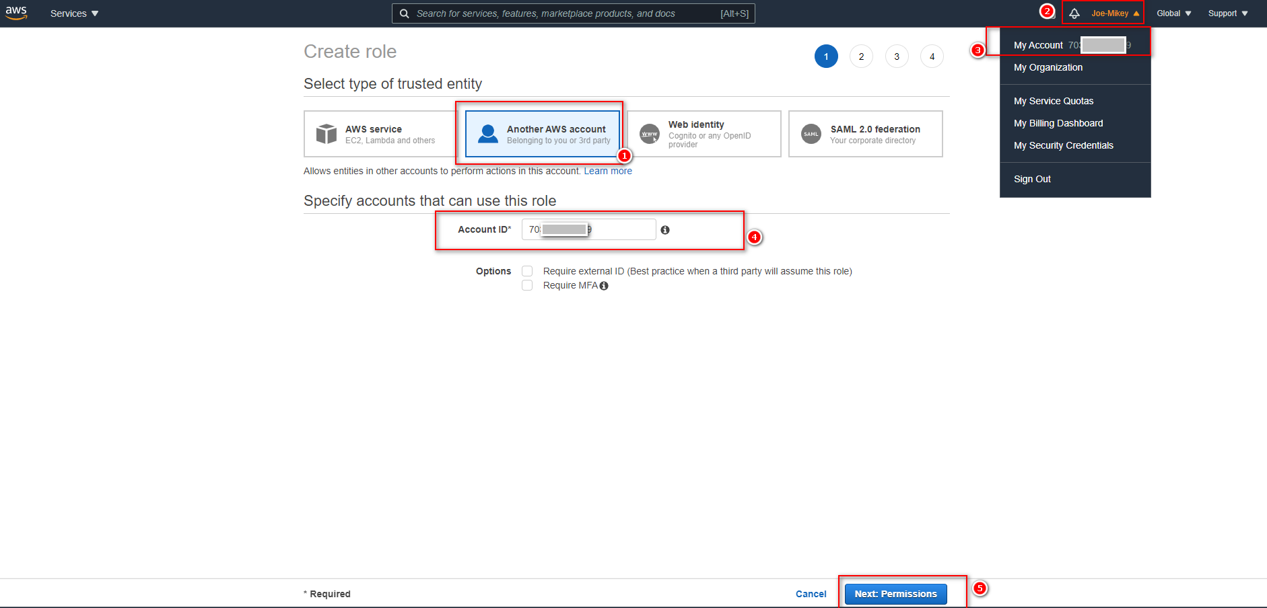

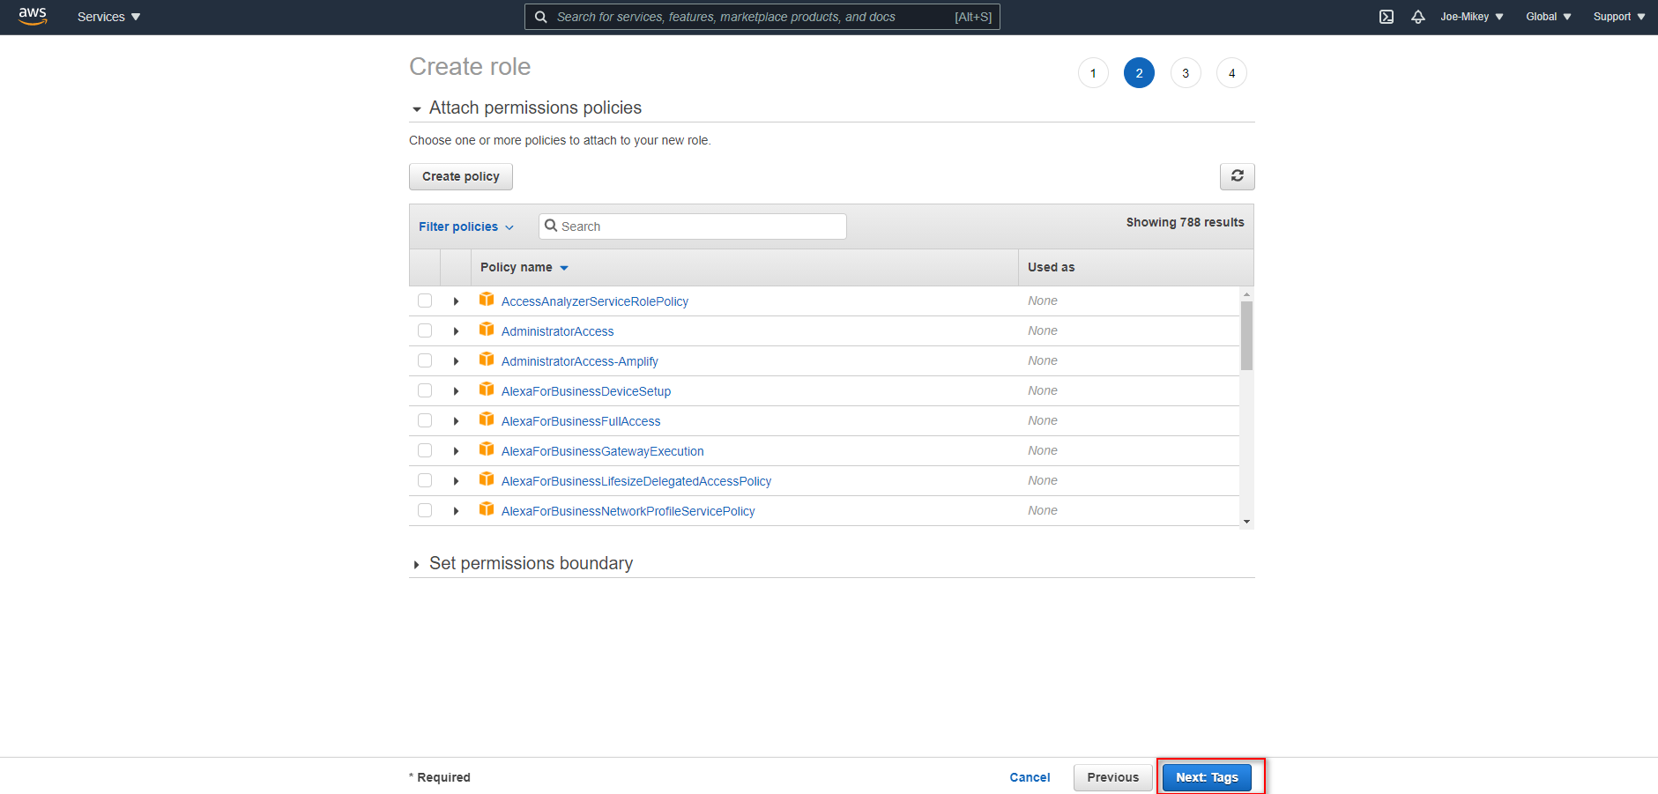

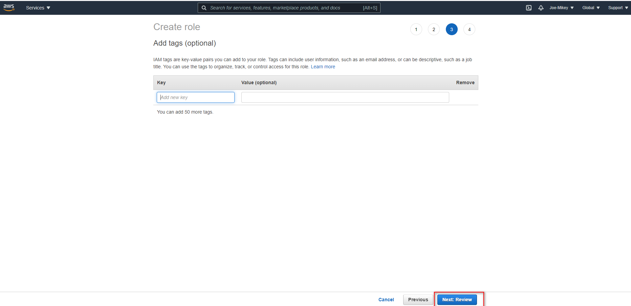

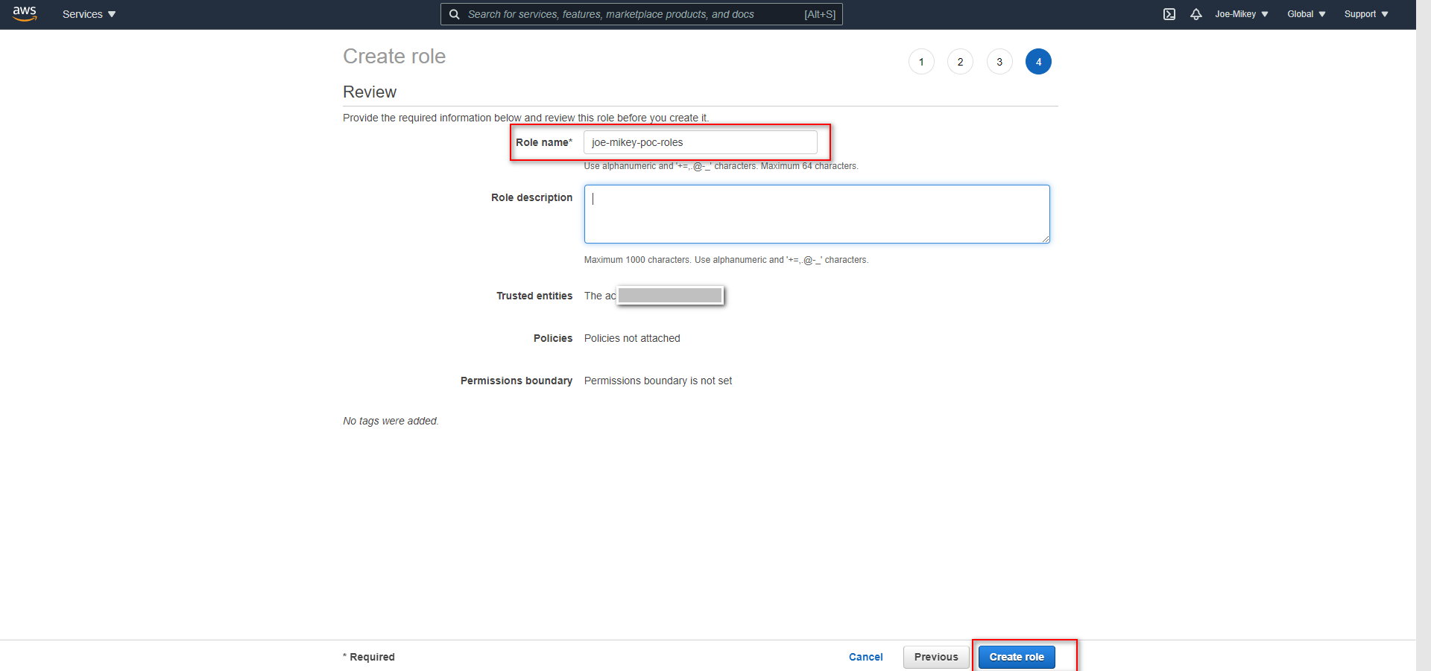

### Edit roles permissions

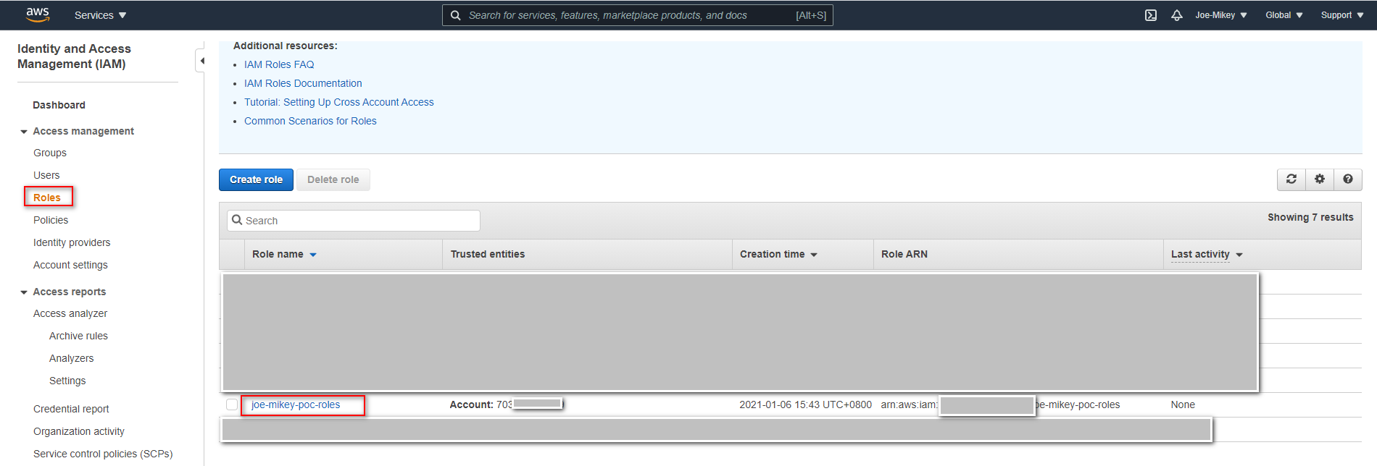

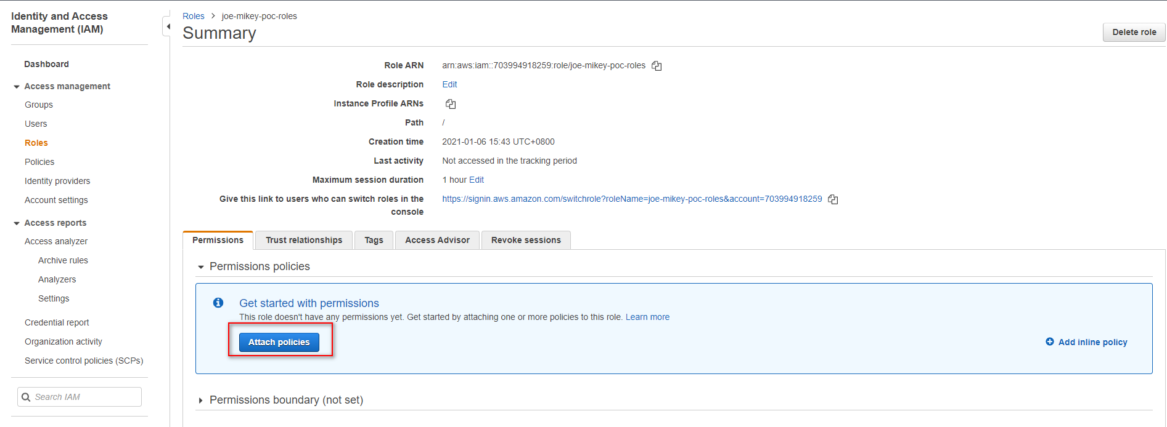

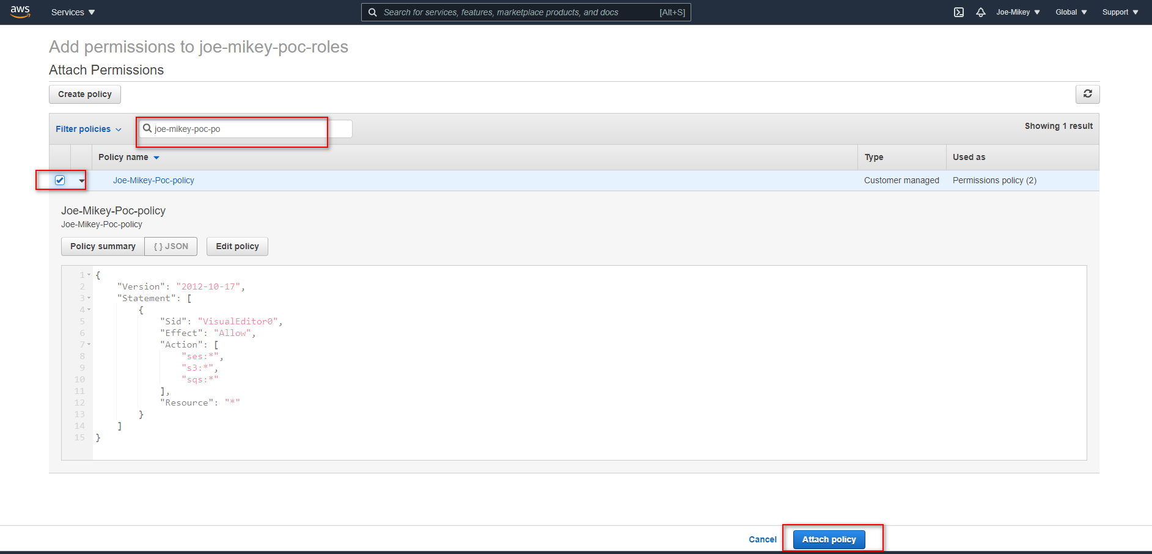

### Edit roles trust relationships

#### Copy user arn

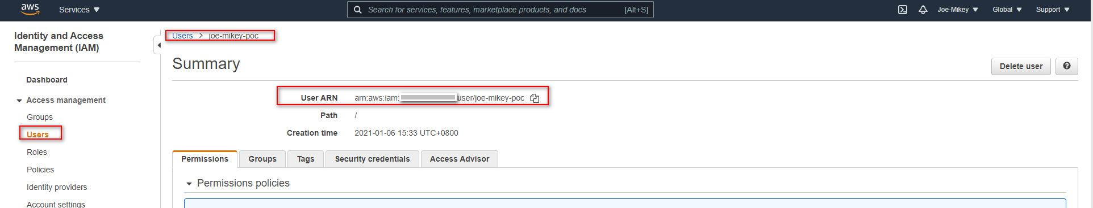

#### Edit trust relationship

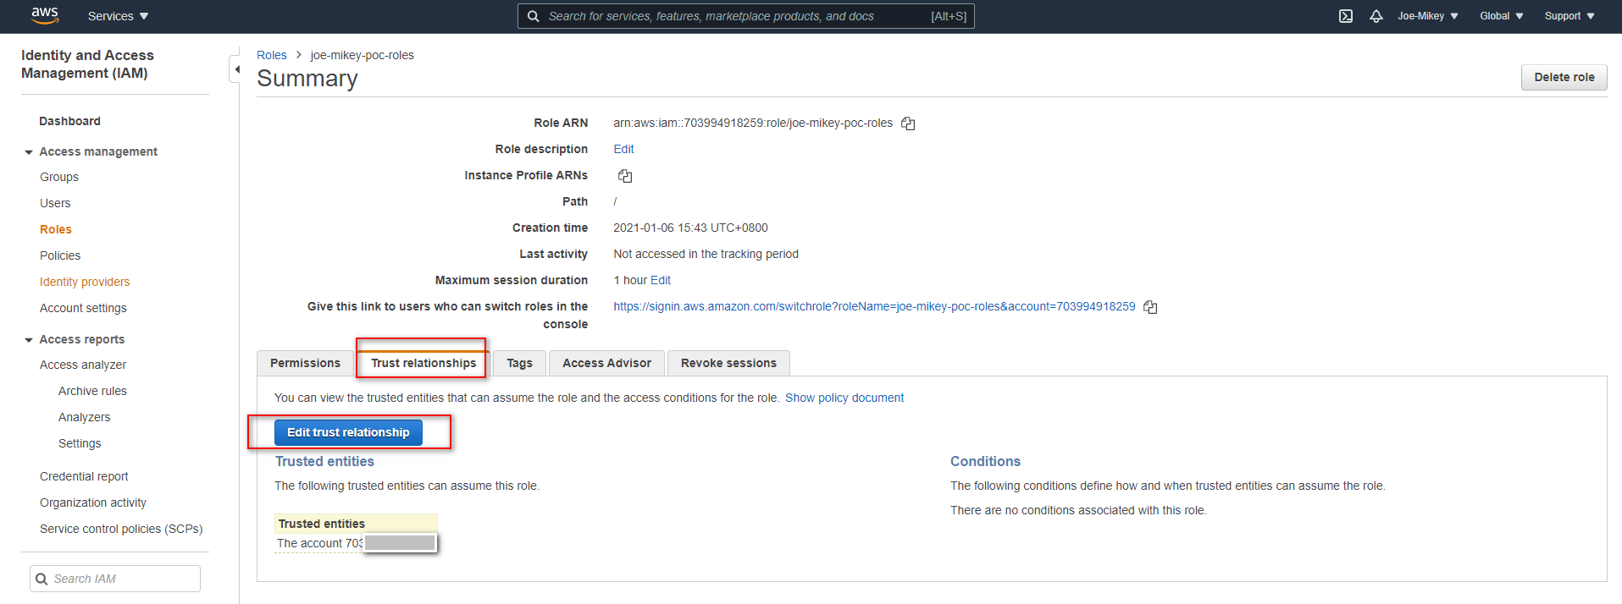

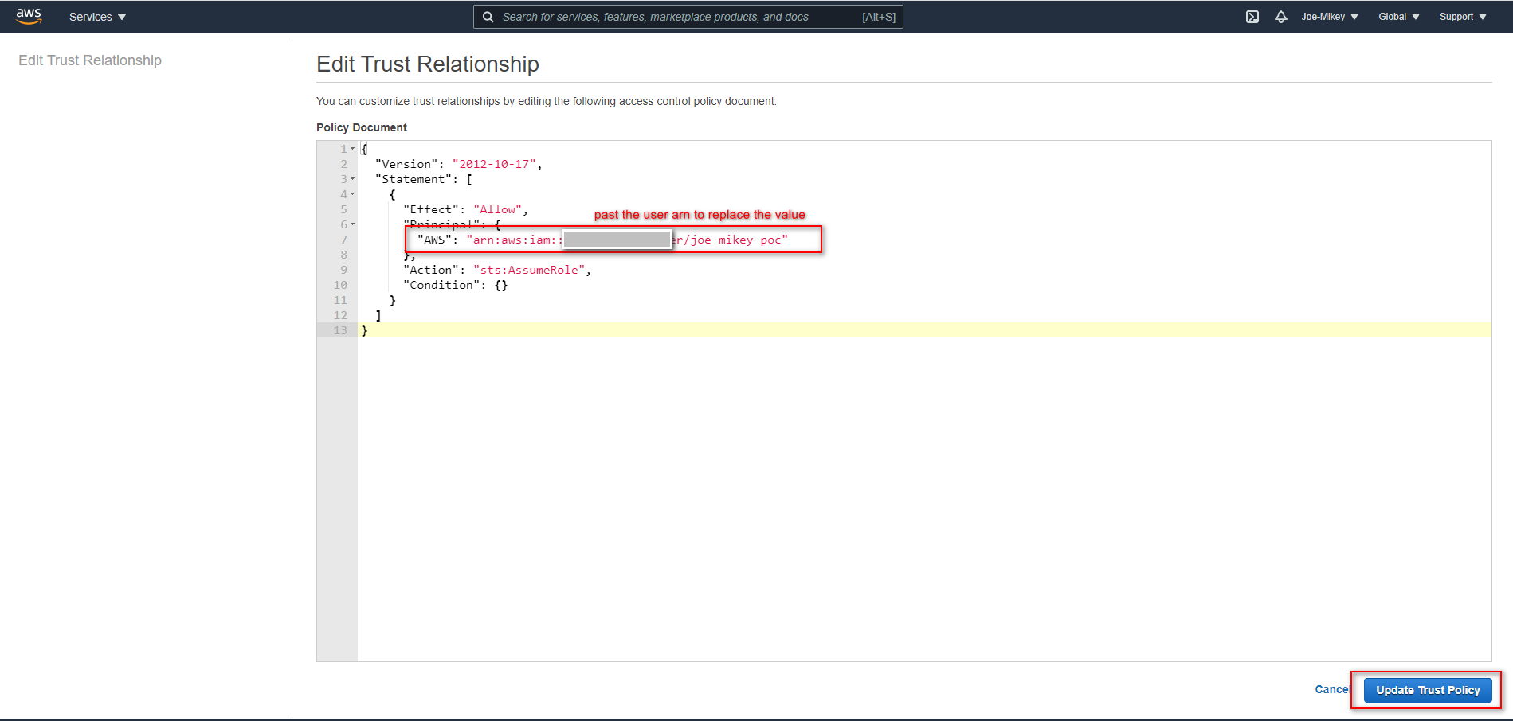

## Replace s3RoleArn, sqsRoleArn

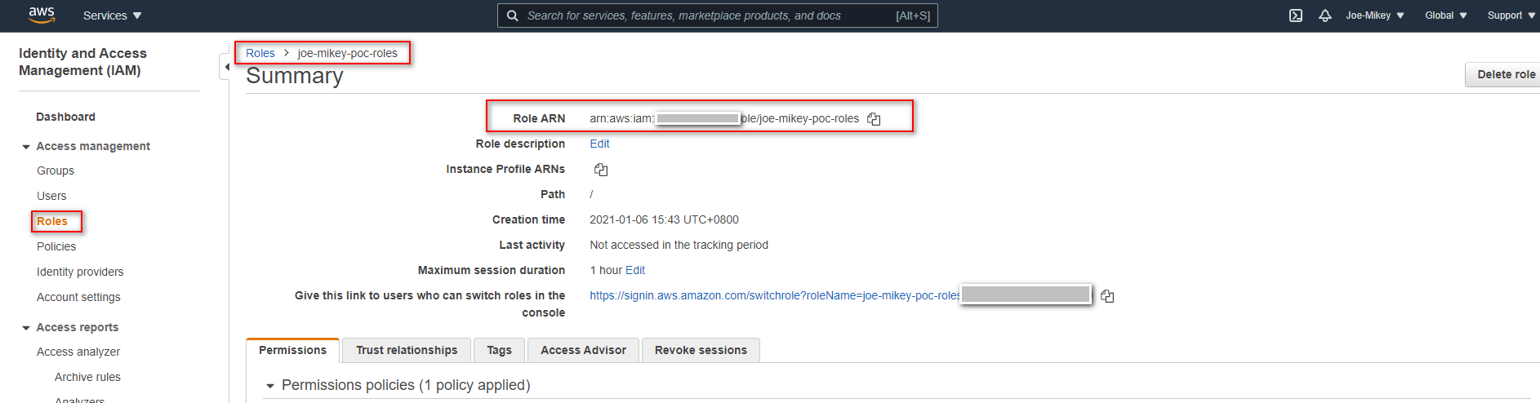

|  |
| --- |
| s3RoleArn: process.env.S3_ROLEARN || "arn:aws:iam::xxx:role/xxx"  sqsRoleArn: process.env.SQS_ARN || "arn:aws:iam:: xxx:role/xxx" |